View Panes

#### Evidence Tree Pane

The Evidence Tree pane (upper-left pane) displays added evidence items in a hierarchical tree. At the root of the tree are the selected evidence sources. Listed below each source are the folders and files it contains.

Click the plus sign  next to a source or folder to expand the view to display its sub folders.

Click the minus sign  next to an expanded source or folder to hide its contents.

When we select an object in the *Evidence Tree*, its contents are displayed in the *File List*. The properties of the selected object, such as object type, location on the storage media, and size, are displayed in the *Properties* pane. Any data contained in the selected object is displayed in the *Viewer* pane.

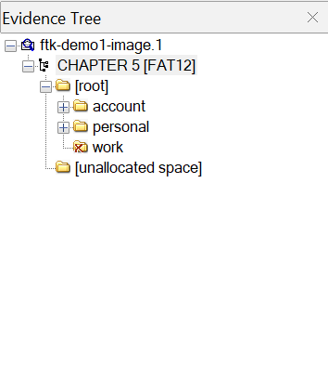

#### File List Pane

The *File List* pane shows the files and folders contained in whichever item is currently selected in the *Evidence Tree*. It changes as our selection changes.

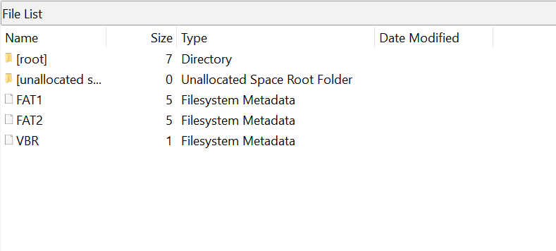

#### Viewer

The *Viewer* shows the content of the currently selected file, based on the Preview Mode selected: Natural, Text, or Hex.

The content can be scrolled through so we can see the entire file content. In addition, with *Hex Mode* selected, and the *Combo Pane Hex Value Interpreter* open, the hex interpretation of text selected in the *Viewer* pane can be viewed simultaneously.

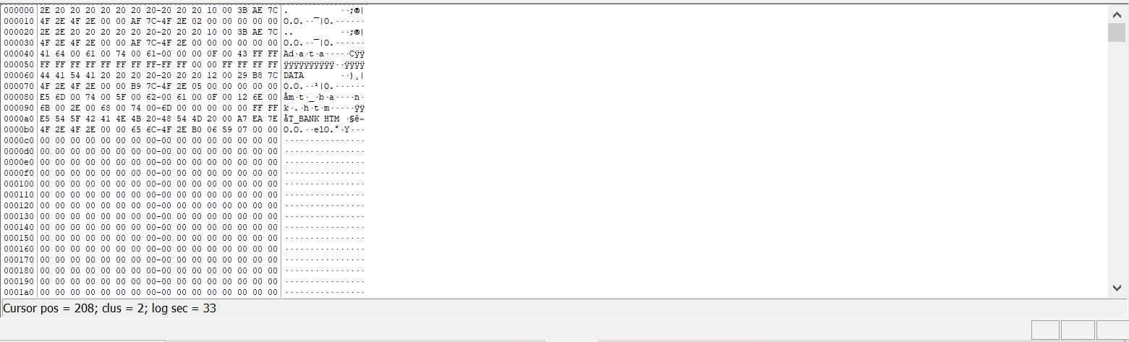

FTK Imager’s lower-left pane has three tabs: *Properties*, *Hex Value Interpreter*, and *Custom Content Sources.*

##### Properties

The *Properties* tab displays a variety of information about the object currently selected in either the *Evidence Tree* or the *File List*.

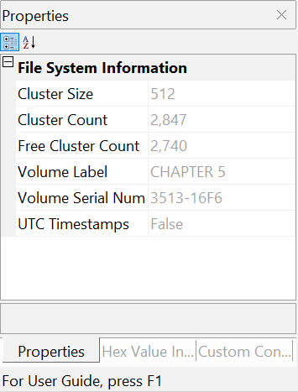

Properties include information such as object type, size, location on the storage media, flags, and time stamps.

##### Hex Value Interpreter

The *Hex Value Interpreter* tab converts hexadecimal values selected in the *Viewer* into decimal integers and possible time and date values.

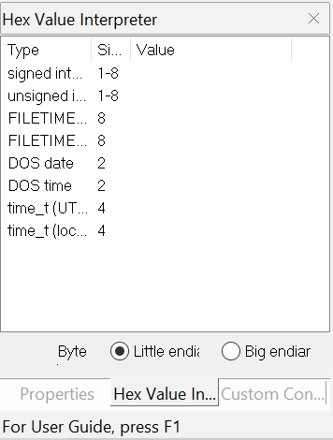

To convert hexadecimal values, highlight one to eight adjacent bytes of hexadecimal code in the *Viewer*. A variety of possible interpretations of the selected code are automatically displayed in the *Hex Value Interpreter*. This feature is most useful if you are familiar with the internal code structure of different file types and know exactly where to look for specific data patterns or time and date information.

##### Custom Content Sources

Each time we add an item to be included in a *Custom Content* image, it is listed here.

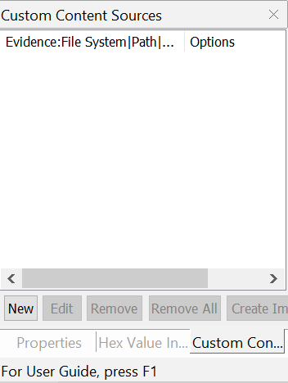

We can add, edit, and remove one or all sources, and create the image from here.